Array

A set of numbers or objects that follow a specific pattern.

*Example: 2 rows of 6 stars*





Multiple

Specifically with reference to naming multiples of 9 and 10.

*Example. 20, 30, 40, etc.*

Product

The quantity resulting from multiplying two or more numbers together.

3 x 4 = 12

Product

Divide/Division

Partitioning a total into equal groups to show how many equal groups add up to a specific number.

*Example; 15 ÷ 5 = 3*

Commutative property

Example: 3 x 2 = 2 x 3

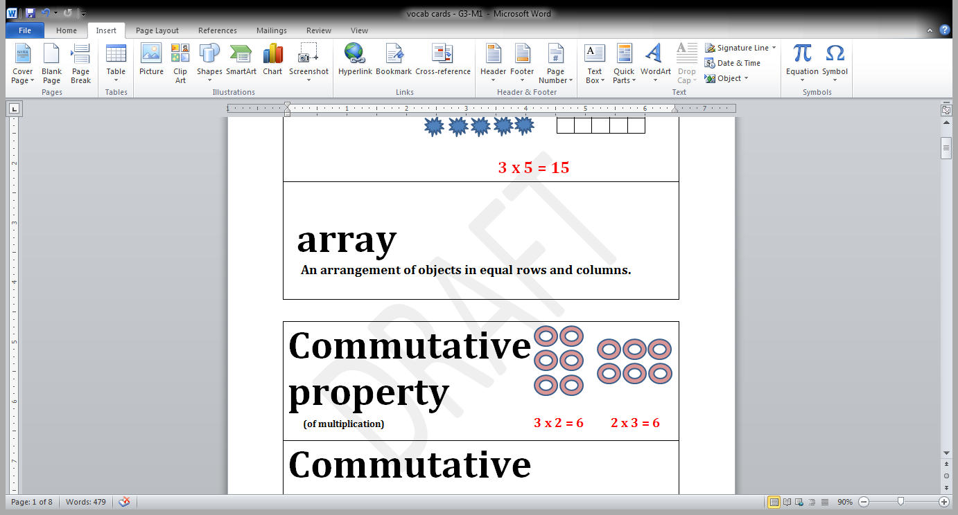

Distribute

With reference to the distributive property.

*Example:* in 12 x 3 = (10 x 3) + (2 x 3), the 3 is the multiplier for each part of the decomposition.

Even number

A whole number whose last digit is 0, 2, 4, 6 or 8.

*Example: 12, 34, 78, 90*

Equal Groups

With reference to multiplication and division; one factor is the number of objects in a group, and the other is a multiplier that indicates the number of groups.

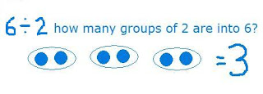

Equation

A statement that two expressions are equal.

*Example: 3 x 4 = 12*

Multiply/multiplication

An operation showing how many times a number is added to itself.

*Example: 5 x 3 = 15*

Expression

A number, or any combination of sums, differences, products or divisions of numbers that evaluates to a number.

*Example: 8 x 3, 15 ÷3*

Factors

Numbers that are multiplied to obtain a product.

3 x 4 = 12

Factors

Number Bond

Model used to show part-part-whole relationships.

 

Number sentence

An equation or inequality for which both expressions are numerical and can be evaluated to a single number.

*Example: 21 > 7 x 2, 5 ÷ 5 = 1*

12

4 3

Odd number

A number that is not even.

*Example: 27, 53, 81, 99*

Ones, twos, threes, etc.

Unit of one, two or three, etc.

Quotient

The answer when one number is divided by another.

*Example: 12 ÷ 4 = 3*

Quotient

Parentheses

The symbols ( ) used around a fact or numbers within an equation, expressions or number sentence.

Row, column

In reference to rectangular arrays.

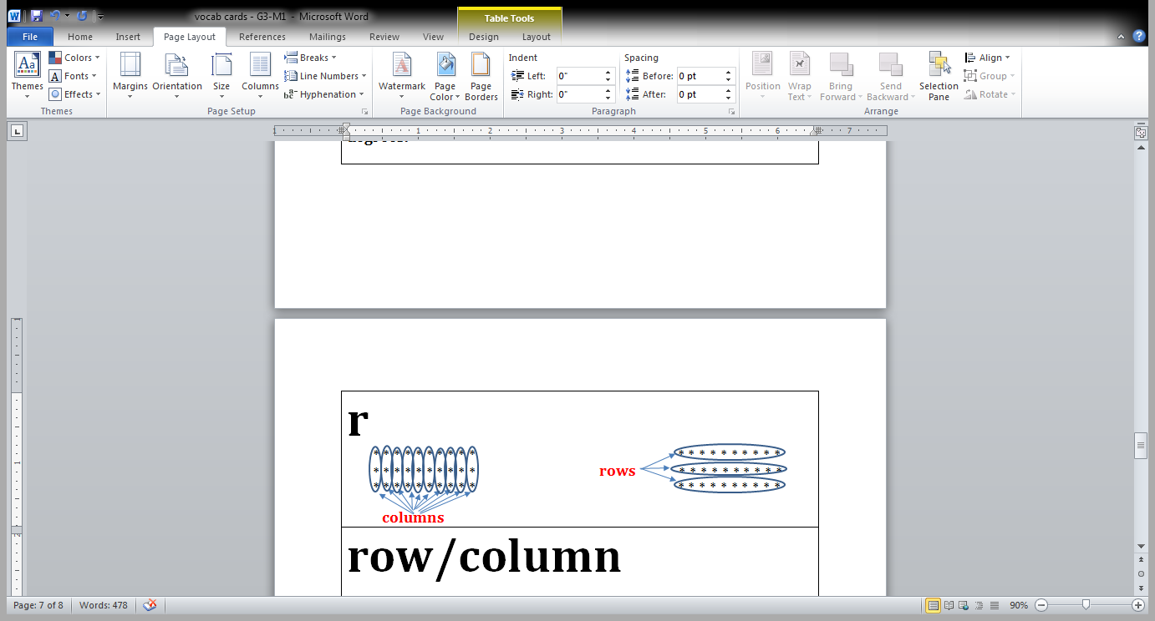

Unit

One segment of a partitioned tape diagram.

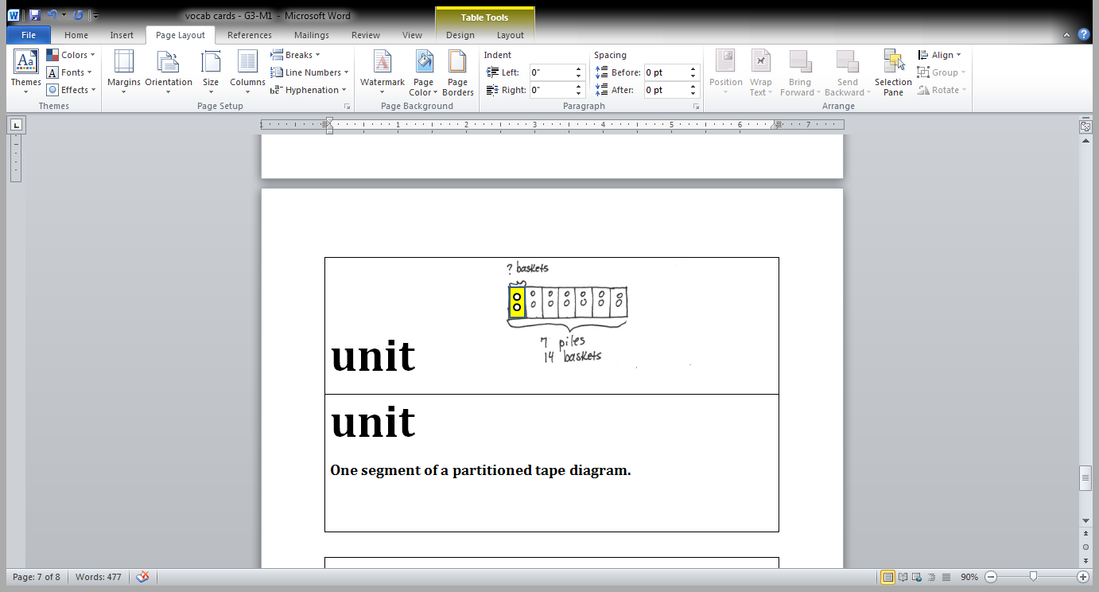

Tape diagram

A method for modeling problems.

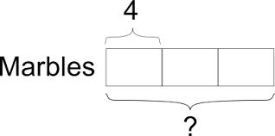

Value

How much.

 What’s the value of each unit? (4 marbles)

Unknown

The missing factor or quantity in multiplication or division.

**3 x ___ = 15**

**____ x 4 = 8**

**25 $÷$ 5 = ____**